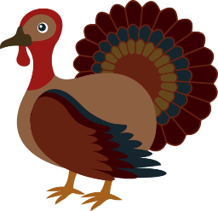
Marketing/Entrepreneurship
Lessons for the Week 11/12 – 11/21
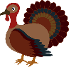
BLK 1—Week #12 & #13

Mon. 11/12: NO School—Veteran’s Day

Tues. 11/13: 1. Business Meeting—Final Vote on class business Philanthropy & sign up for
departments, discussion of how we move forward
Homework: 1.) Research on your business to improve all slides complete so far: 1,2,3,4,5,6,11,14,15 +NOTES

Wed. 11/14: 1. Business Meeting
Homework: 1.) Research on your business to improve all slides complete: 1,2,3,4,5,6,11,14,15 +NOTES

Thurs. 11/15: 1. Work on Slide #10 Competition +NOTES
Homework: 1.) Slide #10 Complete +NOTES

Fri. 11/16: Mrs. Nguyen @ Babson College—Youth Entrepreneurship Summit—
Olivia Nguyen is the Keynote speaker
1. Shelf Space & Slotting Fees Article (@ website) “The hidden war over grocery shelf space” –answer the 4 questions based on the article.
Homework: 1.) Research on your business to improve all slides complete: 1,2,3,4,5,6,10,11,14,15 +NOTES

*****************************************************
Mon. 11/19: 1. E-mail Slides 1,2,10,15 Present Tues. 11/20
2. Discussion of the article from Friday on Shelf Space & Slotting Fees
3. Supermarket Psychology https://www.youtube.com/watch?v=RjgkQ6bq7aE
4. How do I get my product on the shelf? https://www.youtube.com/watch?v=tNzg8d67YFY
Homework: 1.) Present Slides 1,2,10,15 Tues. 11/20

Tues. 11/20: 1. Presentations of Slides 1,2,10,15
Homework: 1.) Research on your business to improve all slides complete: 1,2,3,4,5,6,10,11,14,15 +NOTES

Wed. 11/21: Early Dismissal—11:20a Thanksgiving Break!
- Dress Rehearsal Jan. 11, 2019—Dress Rehearsal Rubric @ website--explained
Homework: 1.) Research on your business to improve all slides complete: 1,2,3,4,5,6,10,11,14,15 +NOTES
2.) Be preparing what you will wear for your dress rehearsal

Have a great Thanksgiving!

